DOS & DONTS
PRE-PLE 2025
HOT SET 3

MATHEMATICS
Time Allowed: 2 hours 30 minutes
Random No. |  |  |  |  |  | Personal No.

Candidate’s Name……………………………………………………………………….
Signature……………………………………………………..………………………........
School Name: …………………………………………………..…………………………
Read the following instructions carefully:
FOR EXAMINERS’ USE ONLY
QN NO. | MARKS | EXR’S  NO.
1 - 5
6 - 10
11- 15
16 - 20
21- 22
23 - 24
25 - 26
27- 28
29 - 30
31 - 32
TOTAL
1. This paper has two sections: A and B.
Section A has 20 questions and section
B has 12 questions. The paper has 15 printed
Pages.

2. Answer all the questions. All the working for
both sections A and B must be shown in the
spaces provided.

3. All the working must be done using a blue or
black ball point pen or ink. Any work done in
Pencil other than graphs and diagrams will
Not be marked.

4. No calculators are allowed in the examination
Room.

5. Unnecessary changes in your work
and handwriting that cannot be read easily may lead to loss of marks.

6. Do not fill anything in the table indicated
“FOR EXAMINERS’ USE ONLY” and in the
boxes inside the question paper.

SECTION :A (40 MARKS)
Answer all the questions in this section
Question 1 to 20 carry two marks.
1. Work out: 16 ÷ 2

2. Write “600,074” in words.

3. If set P = {1, 3, 5, 7, 9} and set QᴜP = {1, 2, 3, 5, 7, 9, 11}. Find n(Q-P)

4. Simplify: -9 - ⁺3

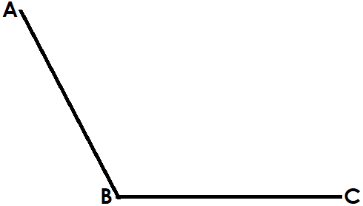
5. Using a ruler a pencil and a pair of compasses only, bisect angle ABC below;

6. Subtract: 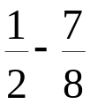

7. Find the next number in the sequence:
6, 7, 10, 16, 26, _______

8. Show a ‘quarter to 7’ on the cock face below;
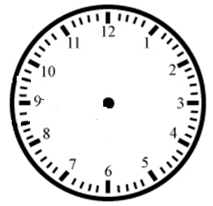
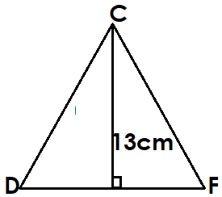
9. The area of triangle CDF below is 130cm². Find the length of the triangle DF.

10. A trader sold a dress at sh. 72000 making a loss of sh. 8000. Express the loss as a percentage.

11. Write XCVI in Hindu – Arabic numerals.

12. Find the range of the numbers; 1, 0, -5, 6, -3 and 9.

13. The LCM of 18 and P is 72 and their GCF is 6. Find the value of P.

14. Given set E = {p, r, t, w, z}, how many proper subsets are in set E?

15. 8 men take 9 days to weed a garden. How many more men are needed to weed the same garden in 6 days?

16. Solve the inequality: 6 – x < - 5.

17. A 29 month course started in May. In which month of the year did it end?

18. Expand 70618 using powers of ten.

19. The interior angle of regular polygon is 150⁰. How many sides does the polygon have?

20. Find the circumference of a circular Kraal of diameter 20m. (Take  = 3.14)

SECTION B: 60 MARKS
Answer all questions in this section
Marks for each question are indicated in brackets
21. a) Change 34 to binary base. (2marks)

b) Expand 212_{three} using powers of three (2marks)

22. At a party, all guests ate chicken (C), (r+4) guests ate both meat (M) and chicken only, (2r – 1) guests ate both fish (F) and chicken only, 16 ate all the three. r guests ate chicken only.
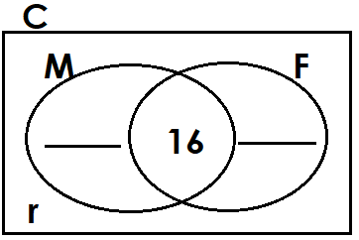
(a) Complete the Venn diagram below. (2marks)

(b) Find the value of r if the guests who ate only two types of sauce were 30. (2marks)

(c) How many guests did not eat fish? (2marks)

23. A tank is 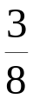 full of water. When 2000 litres of water is added, it becomes 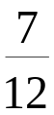 full.
a) Find the capacity of the tank. (3marks)

b) How many litres of water does it hold when it is 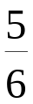 full? (2marks)

24. Mrs. Mugooli bought the following items:
2½kg of wheat four at sh. 5600 per kg
1¾kg of sugar at sh 4400 per kg.
1½ dozen oranges at sh. 3100 for every 6 oranges.
- Calculate her total expenditure. (4marks)

- Calculate the amount she paid is she was given a discount of 10%.

(2marks)
25. In a boutique, a shirt costs four-fifths the cost of a watch while a flask costs sh. 20000 less than a watch. Badru bought a watch, 3 shirts and 2 flasks. If he paid sh. 230000 for all the items, find the cost of a shirt. (5marks)

26. A wooden box containing ceramic jugs weighs 32.2kg. The empty box has a mass of 2.5kg. If each ceramic jug weighs 660g, find the number of jugs in the box. (4marks)

27.(a) Using a ruler, a pencil and a pair of compasses only, construct a parallelogram WXYZ where WX = 7cm and XY = 6cm. Angle WXY= 120⁰. (4marks)

(b) Measure XZ=_________________ (1mark)

28. A motorist driving at a speed of 90km per hour took 2 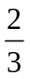hours to travel from J to town K. He rested for 20 minutes before continuing to town C in 2½ hours at a speed of 80km per hour.
(a) How far is town C from town J? (3marks)

(b) Calculate his average speed for the whole journey. (2marks)

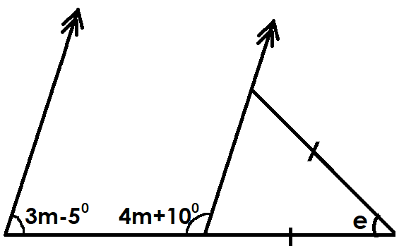
29. Study the figure below and use it to answer the questions that follow:
(a) Find the value of m. (2marks)

(b) Find the size of angle e (3marks)

30. The figures below show a rectangular container (J) and a cylindrical cup (K).

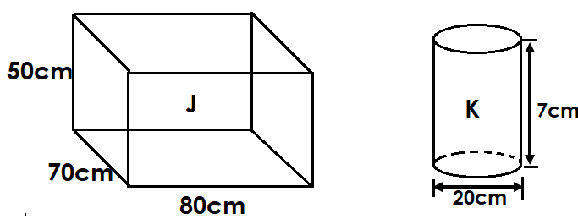

(a) How many cylindrical cups K can be filled in container J? (3mks)

(b) Calculate the volume of the container J left after filling the cups. (2marks)

31. By selling a radio set to Faisal at sh 88000, Anan made a profit of 10%. Faisal then sold it to Kamale at a loss of 15%.
(a) How much did Anan buy the radio set? (3 marks)

(b) Calculate Faisal’s loss. (1mark)

32. The table below shows marks scored by pupils in an exercise.
Marks scored | 5 | 7 | 8 | 10 | 2
Number of pupils | 3 | K | 6 | 5 | 1

(a) Find the value of K if the mean score was 8. (4marks)

(b) How many pupils did the exercise? (1mark)

END

